So you’re taking a college class… now what?

You can pick up your laptop early so you can start your Aims class before we come back to school. Mr. Dalgliesh will send out a message with this date and time.

First…Make sure you know how to log into Aims to access your class!
- Go to Aims.edu.
- Click “my aims login” at the top, right of the page.
- Enter your username. This should be your last name or part of your last name, the first initial of your first name and potentially a number (if you forgot this, follow steps in #4 below or call the phone number in #4 to ask for your username).
- Enter your password. If you do not know your password, click on the “reset password” button below the “login” button and follow the directions. If you do not know your Aims number, call (970) 339-6380 and ask for help finding your Aims ID.

Once you are able to log in to your account, look through the syllabus for your class (could be located under content or syllabus, depending on where the teacher has put it), write down due dates so you can keep track of them, and explore the website so you can start to feel comfortable with it.

Textbooks: You may need to purchase a textbook for your class and Valley does not pay for your books. If paying for textbooks is going to be an issue due to financial hardship, please speak with one of the counselors. In order to find your textbooks, follow the steps below:
- Go to aims.bncollege.com.
- Click on the “textbooks” tab on the top left of the page. The page should say, “Find course materials.”
- The “term” should be “Fall 2018.”
- The “department” is based on your class. For example, Psychology department would be PSY, business department would be BUS, etc. If you do not know what the course department is, you can find this under the catalog/schedule on the main aims page (see image below).
- The “course” will be the number associated with the class you are taking. For example, Into to Business would be BUS 115, meaning you would select 115 for the course number (see image below).
- The “section” will be the letter and number to the right of the CRN (see image below).
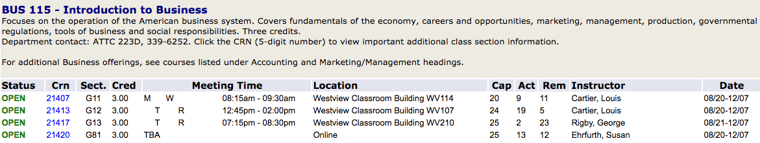
- Click “find materials.”
- You can buy the books through the bookstore, but we suggest looking on different textbook sites to find the cheapest deal. Textbook sites to try:
  - Chegg.com
  - Textbook.com
  - Amazon.com
  - Half.com
  - Slugbooks.com
  - Campusbooks.com

Remember, your class starts before we come back to school at Valley!

Email or call Mrs. Patterson with questions! pattersonm@wcsdre1.org -- (970) 350-4245

